# User Functional Task

The following are the steps in the use of Features in the e-BAST application.

## Login

1. Open the browser and fill the address.  
   Link Address for Telkom Account: [https://ebast-telkom.eidtools.tech](https://ebast-telkom.eidtools.tech/)  
   Link Address for ISAT Account: <https://ebast-isat.eidtools.tech>
2. Enter the username & password.
3. Click button sign in. 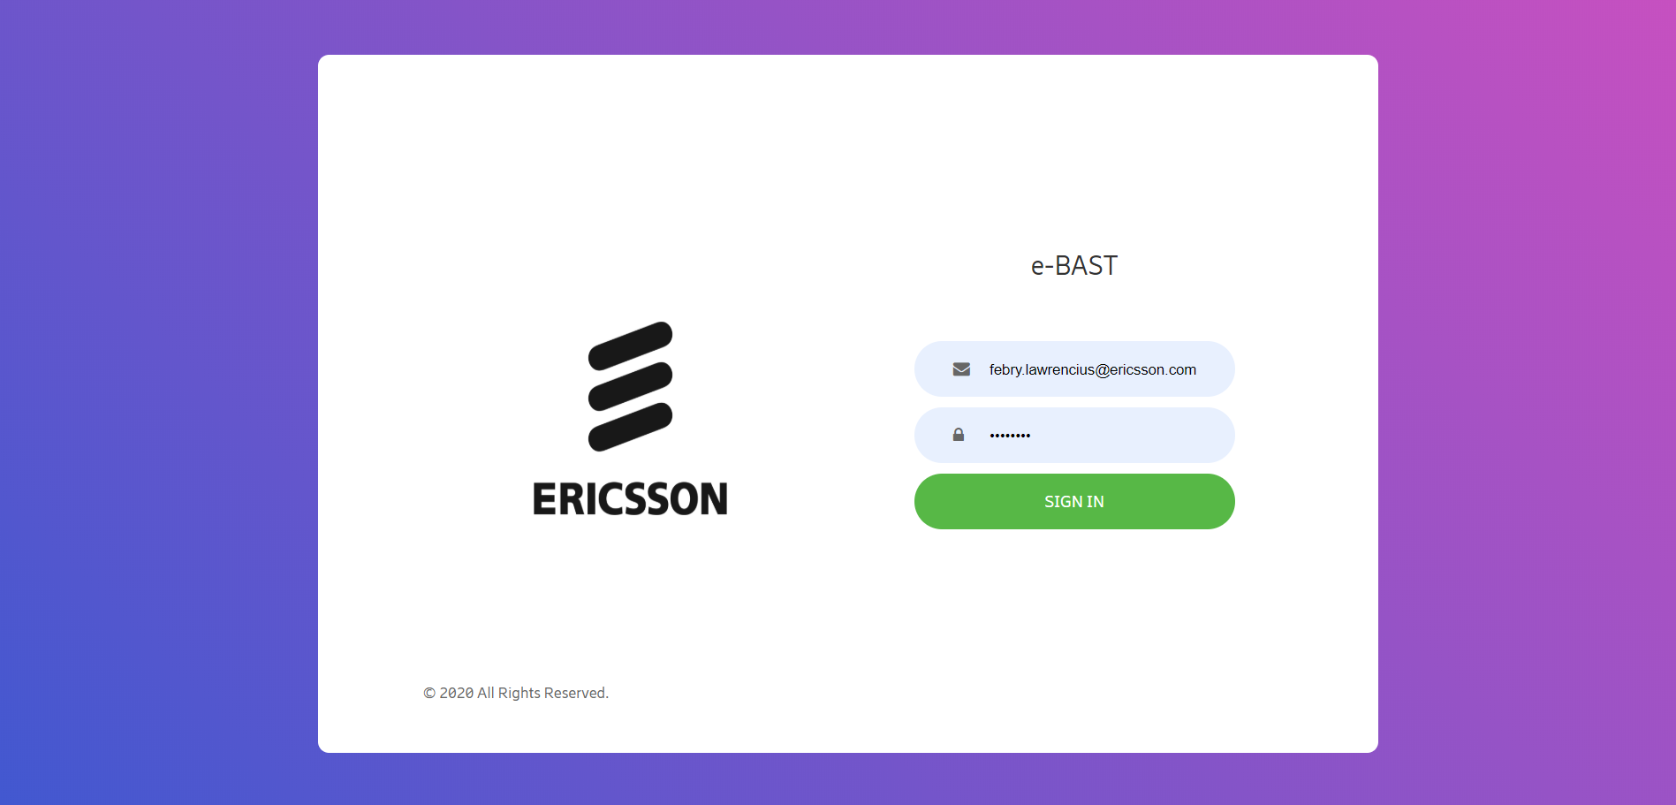

## BAST Pending Approval

1. Login to E-BAST web, then open Dashboard Menu.
2. Click the number of BAST Request Approval 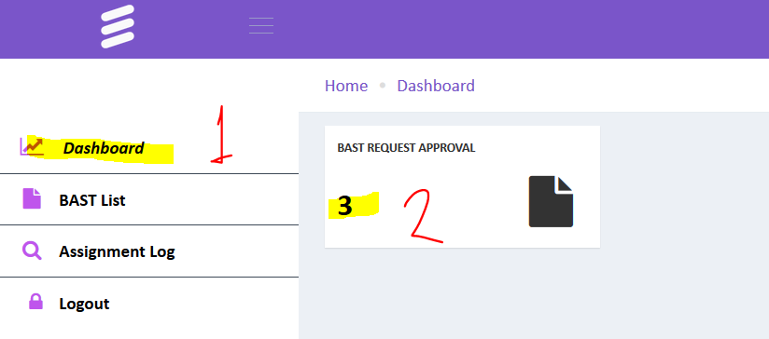
3. You will the see pending BAST.  
   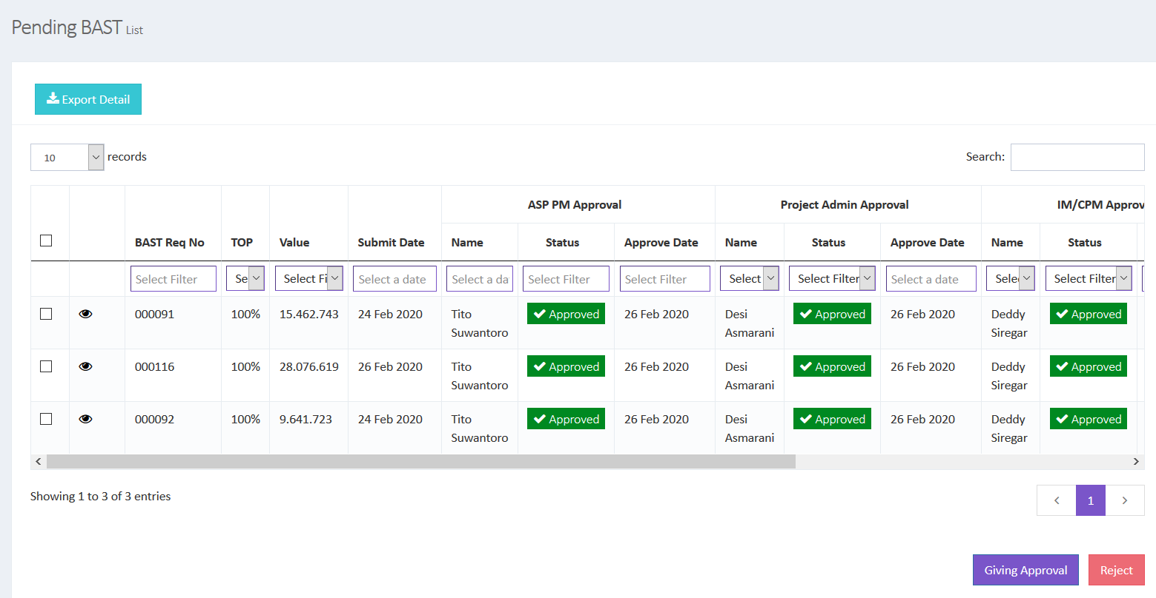
4. To see detail BAST, click 
5. To approve the BAST, tick the checkbox in the first column, then click Giving Approval or you can click Reject button to reject the BAST.

## Extract BAST Data

1. Click Assignment Log menu.
2. Click Export to Excel to extract data to Excel Format.
3. You can search data in table by using searching field.  
   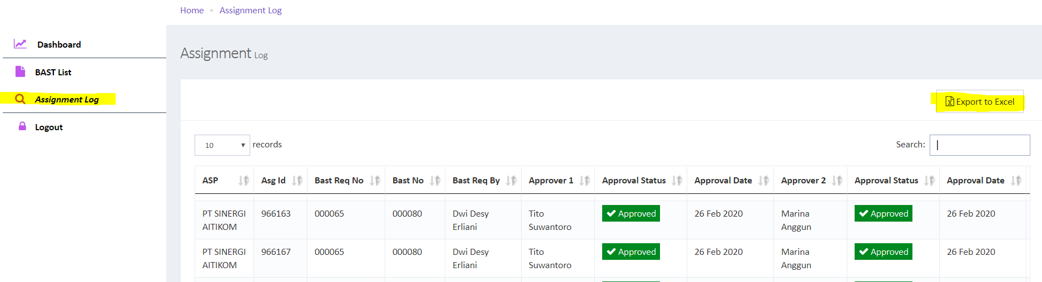

## Monitoring BAST Approval

1. Click menu BAST List.
2. Now you can track approval BAST in the system.
3. You can see the Rejection Reason in the rightmost column.
4. Click button Export To Excel if you want to download the list of data to excel format.  
    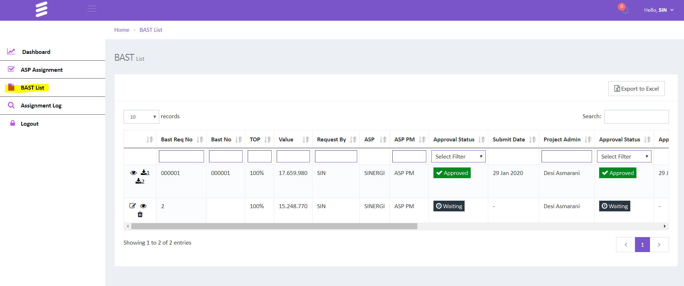

## Download BAST Document

1. BAST Document will generate by system if BAST submission already approved by last approver (TPM).
2. Open BAST List, then click button to generate BAST Page 1 and click  to generate BAST Page 2.

## Contact Support

daniel.robin.manihuruk@ericsson.com (tsel)

ferino.yusron@ericsson.com(tsel)

ismail.rahman.saanin@ericsson.com(xl)

zhafari.oswar@ericsson.com(xl isat)

febry.lawrencius@ericsson.com (isat)